***SCENARIOS:***

|  |  |
| --- | --- |
| **Scenario A:** This is a distribution of test scores. A few students did very poorly; and a few students did very well. Many students did poorly; and many students did well. Most students earned “average” scores on the test. | **Scenario B:**  This is a distribution of test scores. Many, many students did very poorly on the test. Some students scored ‘average;’ and just a few students did very well on the test. |
| **Scenario C:**  This is a distribution of test scores. ***All*** students did either very, very poorly OR did very, very well on the test. | **Scenario D:** This is a distribution of test scores. Every student earned the same exact score. |
| **Scenario E:** This is a distribution of test scores. Many, many students did very well on the test. Some students scored ‘average;’ and just a few students did very poorly on the test. | **Scenario F:** This is a distribution of test scores. Many students did extremely well on the test or very well on the test; and many students did extremely poorly on the test or very poorly on the test. No students did ‘average.’ |

***HISTOGRAM GRAPHICS***:

|  |  |
| --- | --- |
| **Histogram 1:** | **Histogram 2:** |
| **Histogram 3:** | **Histogram 4:** |
| **Histogram 5:** | **Histogram 6:** |

***SUMMARY STATISTICS:***

**Summary Statistics (Roman Numeral) I:**

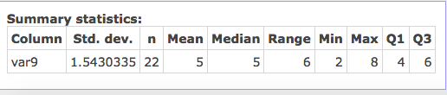

**Summary Statistics (Roman Numeral) II:**

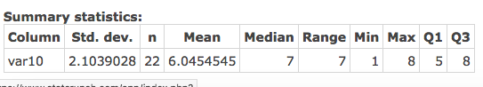

**Summary Statistics (Roman Numeral) III:**

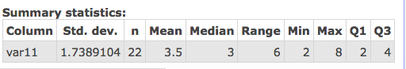

**Summary Statistics (Roman Numeral) IV:**

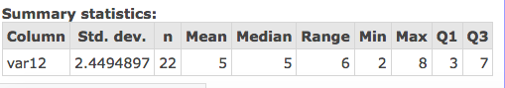

**Summary Statistics (Roman Numeral) V:**

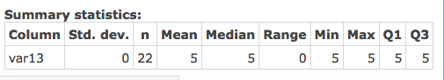

**Summary Statistics (Roman Numeral) VI:**

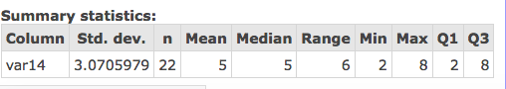

***BOX PLOT/DOT PLOT GRAPHICS***:

**Box Plot**/Dot Plot Graphic Z:

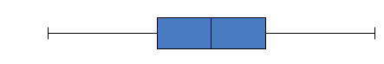

**Box Plot**/Dot Plot Graphic Y:

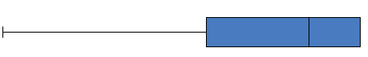

**Box Plot**/Dot Plot Graphic W:



**Box Plot**/Dot Plot Graphic X:

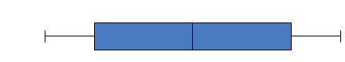

Box Plot/**Dot Plot** Graphic U:



Box Plot/**Dot Plot** Graphic T:

